**Pros and cons of Luxury Vinyl Flooring**

### Are you searching for an inexpensive way to breathe a new life in your room through flooring? Luxury Vinyl flooring tile not only brings about lavish changes but also serenely enhances the atmosphere of your room. With new and luxurious flooring, you get a guideline to decorate your space accordingly. Moreover, it adds a fresh and stylish look to your room.

Let’s discuss the pros and cons of [Vinyl Plank Flooring](https://www.hardwoodgiant.ca/product-category/vinyl-flooring) so that you can make a better decision.

[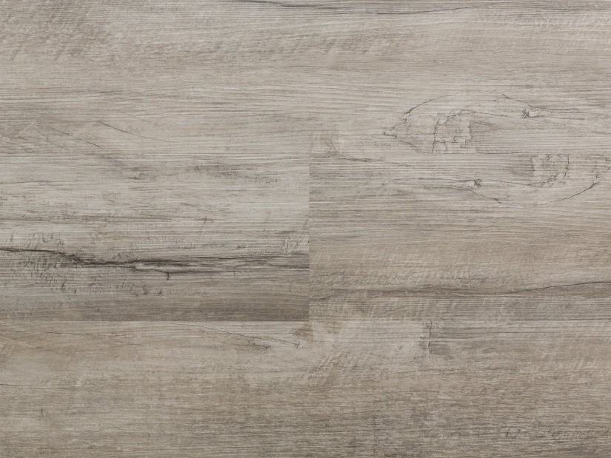](https://www.hardwoodgiant.ca/product/earl-gray)

[**ADD TO CART**](https://www.hardwoodgiant.ca/vinyl-flooring/pros-and-cons-of-luxury-vinyl-flooring?add-to-cart=2990)

Hot Deals

### [**Earl Gray**](https://www.hardwoodgiant.ca/product/earl-gray)

**$1.49**

[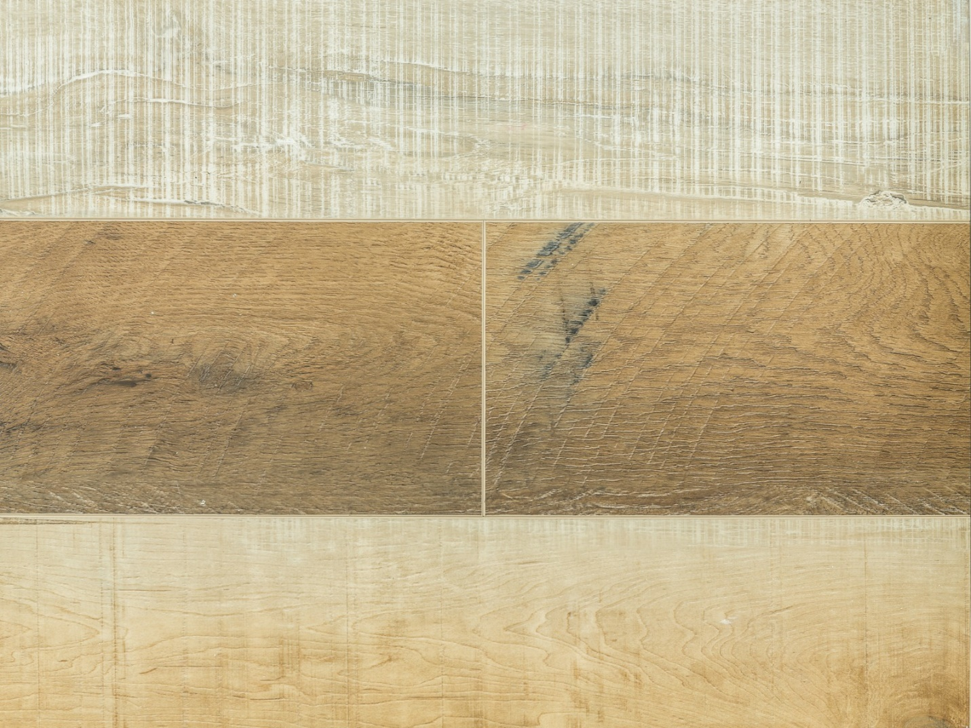](https://www.hardwoodgiant.ca/product/lisbon)

[**ADD TO CART**](https://www.hardwoodgiant.ca/vinyl-flooring/pros-and-cons-of-luxury-vinyl-flooring?add-to-cart=16048)

Free Installation

### [**LISBON**](https://www.hardwoodgiant.ca/product/lisbon)

**$3.19**

[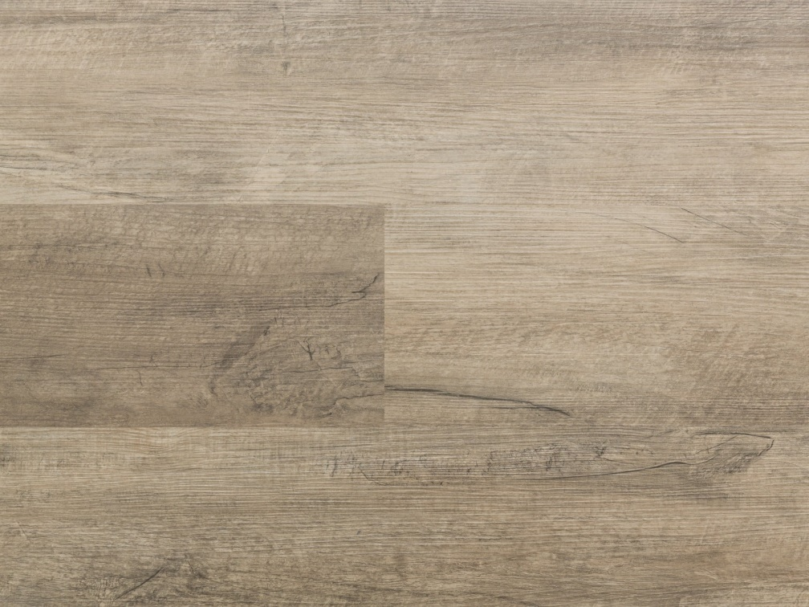](https://www.hardwoodgiant.ca/product/mushroom)

[**ADD TO CART**](https://www.hardwoodgiant.ca/vinyl-flooring/pros-and-cons-of-luxury-vinyl-flooring?add-to-cart=16255)

Hot Deals

### [**Mushroom**](https://www.hardwoodgiant.ca/product/mushroom)

**$1.49**

# Pros of Luxury Vinyl Flooring Tile:

### **1.It’s inexpensive:**

The inexpensiveness of Vinyl Plank Flooring makes it an attractive idea. As compared to wooden flooring, vinyl plank flooring is twice less in pricing. To conserve a couple of thousand dollars, it is a good idea to go for Vinyl Plank Flooring.

### **2.Variety of shades and patterns:**

In the world of luxury vinyl flooring, there are various choices for colors and designs. You can find any design in vinyl flooring easily as a variety of patterns and shades are available. The fantastic thing is that you can have vinyl plank flooring in wood style too.

### **3.Easy installation:**

While flooring your room, you should know what type of flooring will be easy to install. Tiles and wooden flooring are complicated to install and maintain. Moreover, you can trim the vinyl slabs through a knife to fit in any corner or shape of your room.

### **4.Durability:**

Vinyl floors are highly durable and reliable. Spills are easy to clean, and the floor does not absorb them. On the other hand, Wood flooring cannot bear wetness and damping. In addition, the floors of ceramic tiles are vulnerable to breakages, while vinyl floors are versatile.

### **5.Warm and comfortable:**

The most important thing by which vinyl floors get credit is the warmness it maintains. In winter, you do not need to worry about the chills the tile floor gives you. You can enjoy the warmth of the room that stays lock due to the vinyl plank floor.

# Cons of Vinyl plank flooring:

As we have discussed the benefits of vinyl plank flooring, before buying, we should also look at its disadvantages.

### **1.Health risks:**

It’s a less regulated flooring and can release gasses into the house called VOCs. These can cause respiratory issues to people who are vulnerable to allergies. VOC has a smell that stays in your place for ten days. If you are allergic to such a smell, we recommend you don’t opt for vinyl flooring.

### **2.Non-suitable for Wheelchair:**

The planks of vinyl floors are not glued and are floating tiles. Using a wheelchair will cause them to shift a little from the exact place. It is better to mention it to your salesperson and go for the cemented vinyl plank flooring.

### **3.Can fade in the sun:**

There is a chance of fading away of vinyl flooring in the scorching sun. If your room is exposed to the sun all the time through giant windows, it will eventually cause fading of the floor.

# To choose the best vinyl tile, follow these tips:

* Pick a thick wear layer for durable flooring.
* Buy embossed Vinyl tiles as it enhances the look of the floor.
* Ensure the company reputation from which you are buying the LVP.
* Choose the tiles for which the company gives a warranty.